

Hamilton County Sheriff's Office

Simon L. Leis, Jr., Sheriff

MEDIA RELEASE

green township man charged for attempted rape

Green Township, December 2, 2008 -- Sheriff Simon L. Leis, Jr., Hamilton County Sheriff’s Office, Chief Bart West, Green Township Police Department, reports the following:
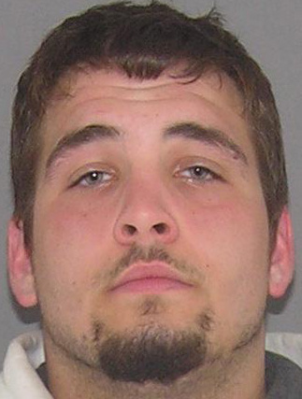
On December 2, 2008 Sheriff’s Detectives charged Robert Super III of the 5900 block Calmhaven Drive, Cincinnati, Ohio with one (1) count of Kidnapping, felony 2; one (1) count of Attempted Rape, felony 1; and one (1) count of Gross Sexual Imposition, felony 3. Super was seventeen years old at the time of the offenses and has therefore been charged in Hamilton County Juvenile Court. Super has been lodged in the Hamilton County Justice Center since November 1, 2008 on unrelated charges. A holder has been placed on the juvenile charges.
The juvenile charges are the result of an investigation conducted by Sheriff’s Detectives and Green Township Detectives of a sex offense that occurred in Green Township on March 1, 2008. On that date a 20 year old female reported she was forcefully grabbed as she was walking to her vehicle on Calmhaven Drive and then drug between two houses where her assailant forced her to the ground, attempted to rape her, and fondled her breasts.
A similar offense occurred in October, 2008, on Starhaven, Green Township, and remains under investigation by the Sheriff’s Criminal Investigation Section.
Anyone with information regarding either offense is asked to call Crimestoppers, 352-3040, or text Crimestoppers, 352-3040 (You don’t have to leave your name and you could get cash for clues), or the Hamilton County Sheriff’s Office, 825-1500.

* * * * *

